Fiber Transceiver/Module Exclusive Inspection microscope
As the widespread of high-speed transmission LC optical transceiver module, the inspection of its performance index is very important. It is super critical to check the whole range and large field of view of the end face when the optical fiber is connected to the port. The two-in-one dual-use magnification bench integrated microscope is the perfect inspection tool，which is exclusively for the edge and core two area inspection.

The diameter of the end face LC module is less than 1mm, once defects are around or at the edge, such as crevasse, crack, or larger dirt, it is very likely to spread and shift the risk to the central position of the core, which causes the unqualified transceiver finally. Therefore, the full range, whole large field of view module end inspection is a must to the high-end transceivers module manufacturers for the QC process and final product audit acceptance.

Large field of view,  full range observation for the LC transceiver  to check the edge,  such as crack, crevasse, or larger dirt. | 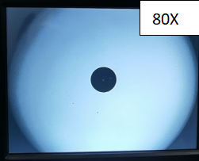 | Needs up and down operation.  Resolution: 2µm  Field of view: 940µm X 690µm
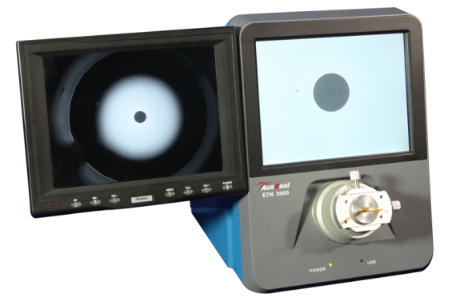 | 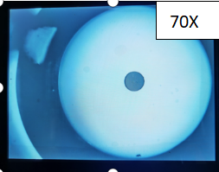 | The whole edge can be checked,  No need for up and down operation.  Resolution: 3µm  Field of view: 1375µm X 1010µm
 | 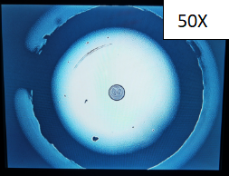 | The opening position of the ferrule ring can be observed,  No need for Up and down operation.  Resolution: 4µm  Field of view: 1720µm X 1620µm

The two-in-one double transceiver module inspection microscope, adds a small rate of 70X or 50X on the traditional 200X scope for two use. Large magnification checks the detailed core area like scratch, dirt, etc., defects while the small rate ensures the whole end face edge(70X) or ferrule ring(50X) for crack, dirt, etc., abnormality. Two images synchronous output on two displays and can be quickly viewed in seconds. It solves the long-time headache test problems for the up and down, left and right position of the inspection kits, which is time-consuming and labor-consuming. It’s the perfect transceiver module inspector tool and achieves the real goal for low cost and high-efficiency inspection requirements.

For one-hand rotating devices kits, one-hand non-stop focusing of the component end-face inspection, the integrated double magnification microscope, is a real sharp tool to end the difficult and complex unnecessary operation, also for the high-end transceiver module, components end face inspection check.

